**24BCP128 Panav Brijesh Patel Div-2 G4**

**Experiment-1**

**Title:** Dataset creation and updating using File Handling Program

**Objective:** How to store and retrieve dataset in table format using file handling programming

**Aim**: To create and update a dataset using a file handling program and import it into MySQL database.

**Theory**: File handling allows us to read and write data into files. We can use Python/Java/C/C++ to create and update text or CSV files, which can then be imported into a MySQL table using the `LOAD DATA INFILE` command.

**Code:**

def add_student():

    print("Enter the details of student in the format (Roll no.,Name,Age,Department)=")

    with open("data.txt","r") as f:

        data=f.read()

    with open ("data.txt","a") as f:

        a=[input() for i in range (0,4)]

        if a[0] in data:

            print("Roll no. already exists")

            c=int(input("Do you want to enter student (0(No)/1(Yes))="))

            if(c==1):

                add_student()

            else:

                return 0

        else:

            f.write("\n")

            f.write(",".join(a))

            f.flush()

            d=int(input("Do you want to enter student (0(No)/1(Yes))="))

            if(d==1):

                add_student()

            else:

                return 0

def read():

    print("Roll no.    Name      Age     Department")

    with open("data.txt", "r") as f:

        while True:

            q = f.readline()

            if q == "":

                break

            r = q.strip().split(",")

            for i in r:

                print(i, end="   ")

            print()

def search():

    b2=input("Enter the roll no. that you want to search=")

    with open("data.txt","r") as f:

        while(1):

            a2=f.readline()

            if (b2 in a2):

               r2=a2.replace(",","  ")

               print(f"Yes the record exits = {r2}")

               return 0

def update():

    b=input("Enter the roll no. whose data you want to update=")

    b2=input("Enter the details of student again in format(Roll no,Name,Age,Department) seperating it with (,)")

    with open("data.txt","r") as f:

        lines=f.readlines()

    for i in range(len(lines)):

        if b in lines[i]:

            lines[i]=lines[i].replace(lines[i],b2)

    with open("data.txt","w") as f:

       f.writelines(lines)

def delete():

    b=input("Enter the roll no. whose details you want to delete=")

    with open("data.txt","r") as f:

        lines=f.readlines()

    for i in range(len(lines)):

       if b in lines[i]:

          del lines[i]

    with open("data.txt","w") as f:

       f.writelines(lines)

while(1):

  print("Enter for number given choice: \n 1.Add a student record  \n 2.View all records \n 3.Search a record by roll no. \n 4.Update a record \n 5.Delete a record \n 6.Exit")

  b=int(input())

  match b:

    case 1:

      add_student()

    case 2:

      read()

    case 3:

      search()

    case 4:

      update()

    case 5:

      delete()

    case 6:

      exit()

**Output:**

**Experiement-2**

**Title**: DDL (Data Definition Language) commands

**Objective**: To understand how to create tables and insert different types of datatypes in a table.

**Aim**: To use various DDL commands like CREATE and INSERT.

**Theory**: DDL commands are used to define the database structure or schema. They do not manipulate data but affect table definitions and structures.

**Code and Output exercise wise:**

**Exercise-1:**

**Code and Output:**

**Code and Output:**

**Exercise-2**

**a)**

**b)**

**c)**

**Experiement-3**

**Title:** DDL commands with constraints.

**Objective:** To understand how update values as well as the attributes a table and also how to delete a given table and how to display the contents of the table conditionally.

**Aim:** To use various DDL commands like SELECT, UPDATE, WHERE, DELETE, ALTER and DROP.

**Theory:** These commands help us to manipulate data in a table also helps us display only the data that we want by giving constraints.

**Code/Output:**

**1.Exercises on retrieving the data from**

**a.** Find out the names of all the clients.

**Code and output:**

**b.** Retrieve the entire contents of the Client_Master table.

**Code and output:**

**c.** Retrieve the list of names, city and the state of all the clients.

**Code and output:**

**d.** List the various products available from the Product_Master table.

**Code and output:**

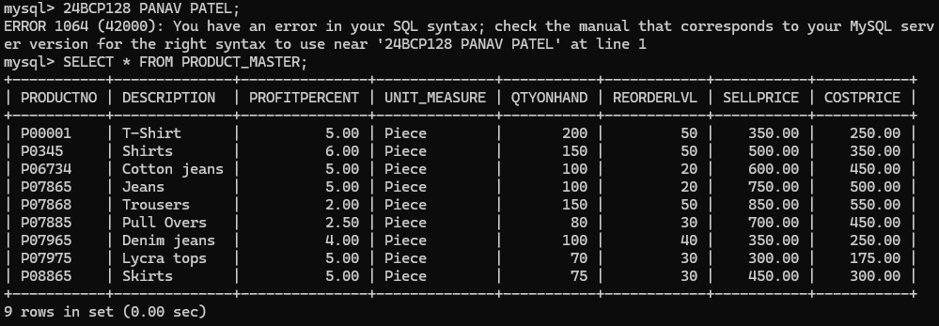

**e.** List all the clients who are located in Mumbai.

**Code and output:**

**f.** Find the names of salesman who have a salary equal to Rs.3000.

**Code and output:**

**l.** Find the names of salesman who have a salary equal to Rs.3000.

**a.** Change the city of ClientNo ‘C00005’ to ‘Bangalore’.

**Code/Output:**

**b.** Change the BalDue of ClientNo ‘C00001’ to Rs.1000.

**Code/Output:**

**c.** Change the cost price of ‘Trousers’ to rs.950.00.

**d.** Change the city of the salesman to Pune.

**Code/Output:**

**2.Exercises on deleting records in a table**

**a.** Delete all salesman from the Salesman_Master whose salaries are equal to Rs.3500.

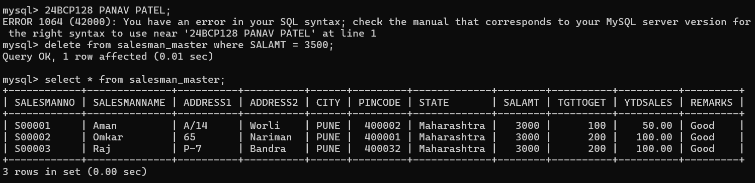

**b.** Delete all products from Product_Master where the quantity on hand is equal to 100.

**c.** Delete from Client_Master where the column state holds the value ‘Tamil Nadu’.

**3. Exercise on altering the table structure.**

**a.** Add a column called ‘Telephone’ of data type integer to the Client_Master table.

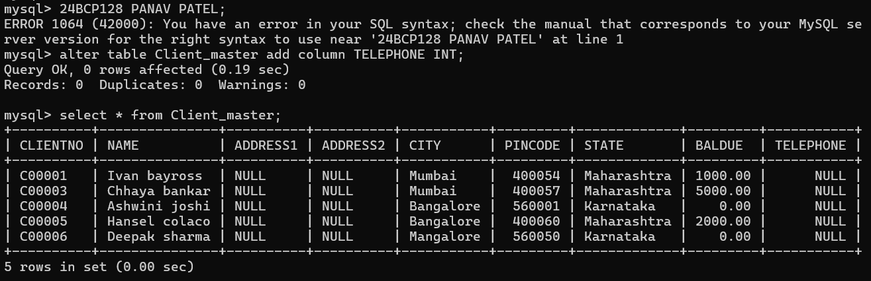

**b.** Change the size of SellPrice column in Product _Master to 10, 2.

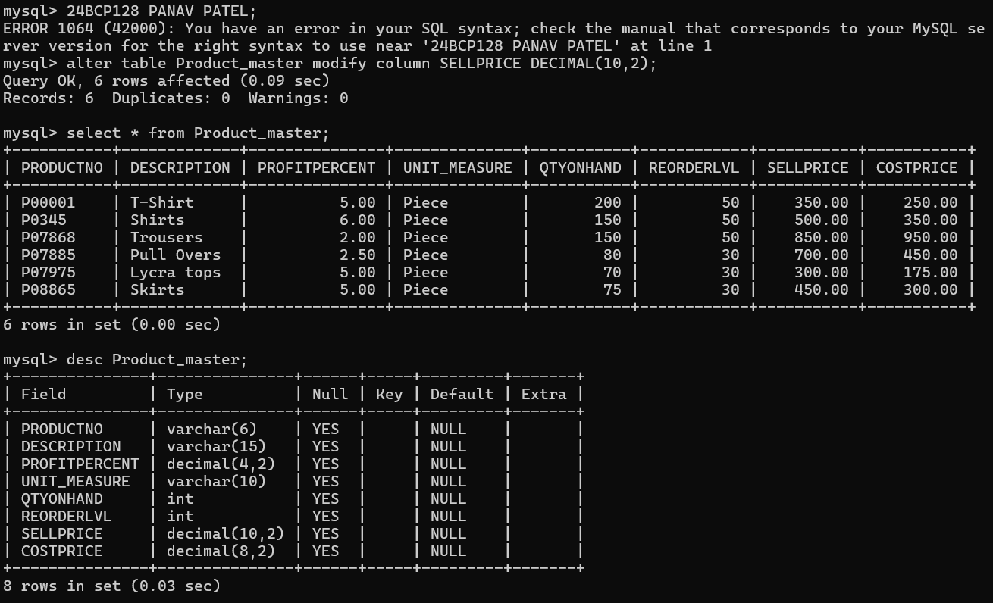

**4.** **Exercise on deleting the table structure along with the data.**

**a.** Destroy the table Client_Master along with its data.

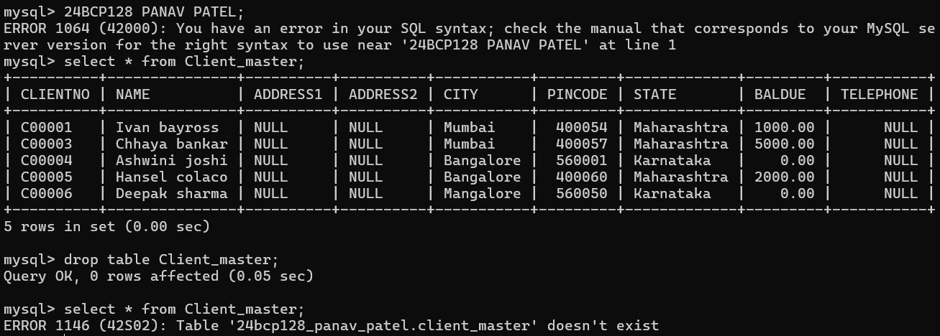

**5.** **Exercise on renaming the table.**

**a.** Change the name of the Salesman_Master to sman_mast.

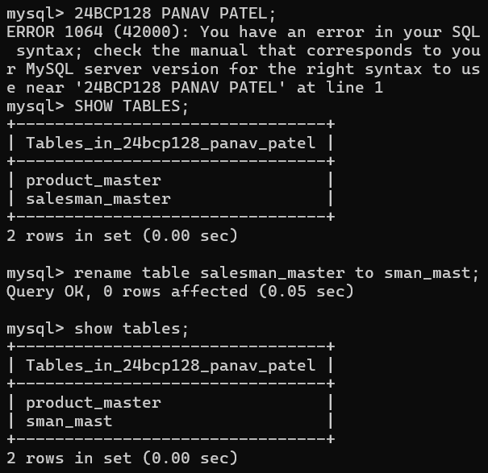

**Experiement-4**

**Title: DDL (Data Definition Language) commands with Data Constraints**

**Objective:** To understand the concept of data constraints that is enforced on data being stored in the table. Focus on Primary Key and the Foreign Key

**Aim:** To define tables using constraints such as PRIMARY KEY, FOREIGN KEY, etc.

**Theory:** Constraints are used to maintain accuracy and integrity of data.

**Exercise**

**1.Create the tables described below:**

**Table name: CLIENT_MASTER_1**

**Description:** used to store client information.

**Code/Output:**

**Table Name: PRODUCT_MASTER_1**

**Description:** used to store product information

**Code/Output:**

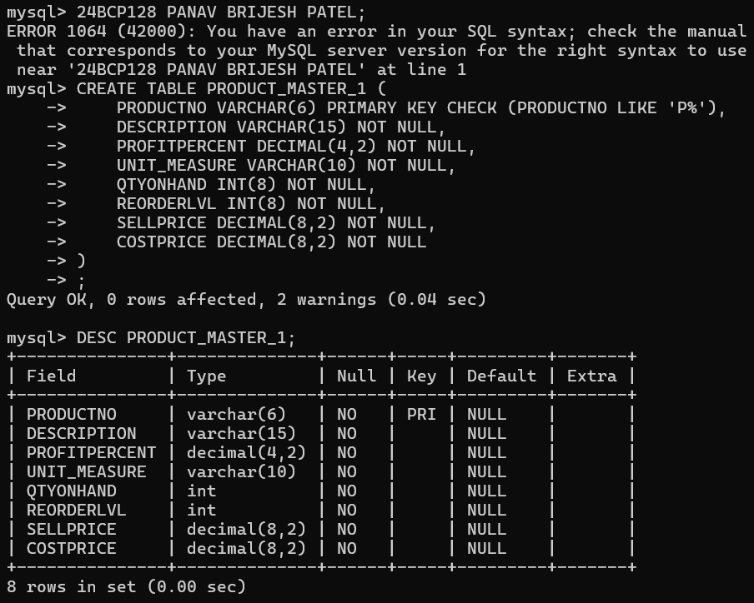

**Table Name: SALESMAN_MASTER _1**

**Description:** used to store salesman information working for the company.

**Code/Output:**

**2.Reinsert the data in these three tables based upon Lab 2.**

**Code/Output:**

**3.Display the contents of each table.**

**Code/Output:**

**Experiement-5**

**Title: DDL (Data Definition Language) commands with Data Constraints**

**Objective:** To understand the concept of data constraints that are enforced on data being stored in the table. Focus on Primary Key, The Foreign Key and constraints.

**Aim:** To implement Data Control Language commands like GRANT and REVOKE.

**Theory:** DCL deals with rights, permissions, and other controls of the database system.

**Exercise**

**1.** Create table AUTHOR = {Author_ID , Lastname, Firstname, Email, City, Country} Where:

Author_ID – text data type, 5 characters, primary key

Lastname – text data type, 15 characters, not null

Firstname – text data type, 15 characters, not null

Email – text data type, 40 characters

City – text data type, 15 characters

Country – text data type, 15 characters

**Code/Output:**

**2.** Create Table BOOK={ Book_ID, Book_Title, Copies}

Where:

Book_ID – text data type, 5 characters Primary Key Start with Character B

Book_Title - Text data Type Not Null

Copies- No.of copies Data Type int always greater the 2

**Code/Output:**

**3.** Create table AUTHOR_LIST = {Author_ID, Book_ID , Role}

Where:

Author_ID – text data type, 5 characters, referenced by Author_ID from AUTHOR table Book_ID – text data type, 5 characters Role – text data type, 15 characters and primary key is Author_ID, Book_ID

**Code/Output:**

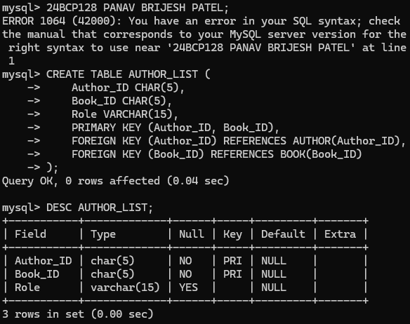

**4.** Add four records in each tables AUTHOR, BOOK, BOOK_LIST.

**Code/Output:**

**5.** Alter structure of table AUTHOR_LIST add the field Publisher data type of 30 Character.

**Code/Output:**

